State of Israel

Ministry of Health

IMCA – Israeli Medical Cannabis Agency

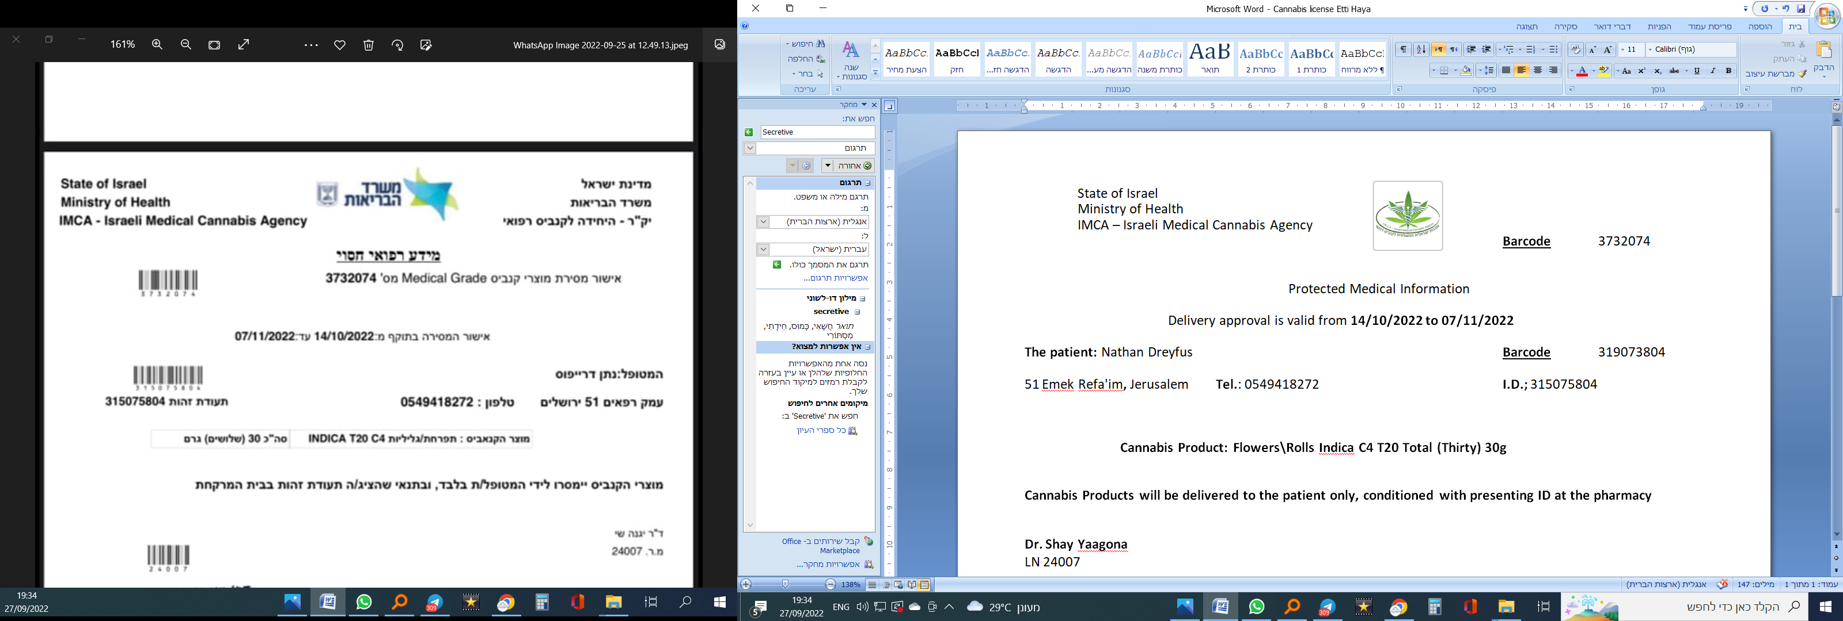**License number:** ______

**Licensed to hold and** **use of adangerous narcotic.**

**Under section 7 to the Dangerous Drugs Ordinance (new version) 5733 - 1973**

By virtue of section 7 to the Dangerous Drugs Ordinance (new version) 5733 - 1973 (Hereinafter: "The Ordinance"), and under the dangerous drugs regulations 5739 - 1979 (Hereinafter: "The regulations"), is hereby granted the license to hold and use a dangerous narcotic. As these terms are interpreted in the Ordinance, and as described below:

**Applicant for the permit and his details:**

|  |  |  |  |
| --- | --- | --- | --- |
| Last name; __________ | First name; __________ | I.D.; _____________ |  |
| Street: ____________ | House number: ________ | Apartment: ____ | City: _________ |
| Zip code: ________ | Tel.: __________ | Mobile phone: _________ |  |

**Name of the dangerous narcotic**: **CANNABIS** **Form: ______________________**

**Held and used for**: For self use only. Under medical supervision. For the purpose of alleviating his medical condition.

The applicant stated that the dangerous drug is not for use in any purpose not approved in the license.

**The designated place** **to hold or use**: Address of the applicant at the address listed above, without the presence of another person while being used, and any other place which is specifically permitted by the Administrator, whether it's a private permit or a general permit, which was published on the office website, and any other permit which was given, published, wasn't changed or cancelled.

**Supply**: Authorized pharmacy for distributing Cannabis

**Restrictions andconditions:**

1. This is only a temporary license. This license can be canceled, inter alia, as per the Administration's decision, and that is without derogating from any other legally grounds to cancel the license.
2. This license is personal and is not transferable in any manner whatsoever.
3. When using the dangerous drug, it is strictly forbidden to perform any activities that require concentration including driving and/or operating heavy machinery.
4. It is absolutely forbidden to use the dangerous drug in the presence of minors.
5. The applicant must notify the Administration of any change in address in order to amend the details of this license.
6. The applicant shall take measures to prevent the loss and theft of the drug and inform police immediately about the theft, attempted theft or loss of the dangerous drug as stipulated in regulation 9.
7. Chapter 5 of the regulations does not apply to the applicant, except regulation 24(B) of this chapter, that shall apply mutatis mutandis.
8. This license is not a substitute for medical consultation with a licensed medical Health-care entity in all regarding the dangerous drug, its effects by using the drug, its side effects, risks arising from it, etc.
9. Its use shall be monitored and followed-up by **Dr. Yaacov Fogelman** who will report to the Administration regarding the applicant's condition.
10. **This license cancels any other license the applicant holds and/or is in his name.**

**Stamp and Signature**

**Dr. ________________ ‎**

LN ______ LLN _______

Dr. ____________________

Administrator under the Dangerous Drugs Ordinance

License validity: **From**: __/__/__ **Till**: __/__/__